Form 0717. Student Life Acknowledgement of Food and Beverage Guidelines for Clubs and Organizations
INSTRUCTIONS

- This acknowledgement form is for Clubs and Organizations planning to provide food and drinks during an event (either for fundraising purposes or not) and should be submitted to the office of Student Life along with Form 0715. Club-Organization Event Proposal Request Form for approval.
- Please note that only registered Gold Clubs may fundraise and collect money. All fundraisers must be approved by Student Life first.
Part A: EVENT DETAILS

Club(s) Name(s): | Campus:
Name of Event: | Date of Event:

Please indicate the type of event you are planning to host for which you will be providing food (Check only one):
- A. Small meeting or gathering for members only (not selling anything)
- B. Event for members and other students (not selling anything)
- C. Event for members and other students to sell and fundraise on campus property
- D. Event for members and other students to sell and fundraise outside campus with a restaurant.

Part B: ACKNOWLEDGEMENT OF GUIDELINES
Below, please identify the guidelines that you must consider (indicated with a check mark) based on the type of event you are planning, A, B, C, or D:

CLUB or ORGANIZATION MUST | Event A | Event B | Event C | Event D | Your Initials
Read and follow the NOVA Guidelines for the Service and Selling of Food and Beverage on Campus by Student Organizations (Read Appendix A, page 4) |  |  | 
Display cards next to each food providing the following information:
- List of ingredients and allergens next to each food and beverage offered.
- Make the distinction between homemade, prepacked, and restaurant made food next to each food and beverage offered.

Inform each student about the possible risks of allergies
(Read Appendix B, page 5)

Club members or individuals manipulating food and beverages must wear food safety and use clean serving utensils.

With prepackaged items bought from a store such as individual bags of chips, granola bars, candy bars, etc.:
Please ensure that the food information is visible for students prior to consumption.

With prepared food from a RESTAURANT or STORE such as tacos, ramen, BBQ, sandwiches, kebabs, etc.:
Please ensure that the information is visible for students prior to consumption.

With baked goods bought from a store, such as packaged and prepared goods from a professional bakery, etc.:
Please ensure that the food information is visible for students prior to consumption.

With homemade baked goods, brownie trays, cookies, etc.

With drinks bought from a store and prepacked in individual containers, or bulk mixed and poured into cups etc.:
Please ensure that the food information is visible for students prior to consumption.

With homemade drinks prepared at home or during the event:
Please display mixing ingredients and containers for students to see how the drinks are made and ensure that information is visible for students prior to consumption.

Part C. What types of food and beverages are allowed, and which ones are not?

 | Event A | Event B | Event C | Event D
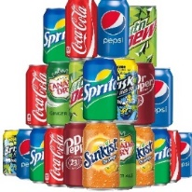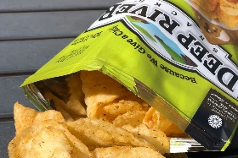 | YES | YES | YES | YES
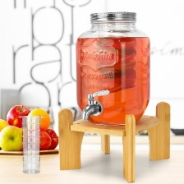 | YES | YES | YES | YES
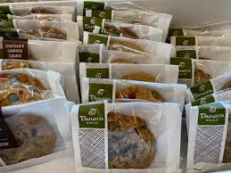 | YES | YES | YES | YES
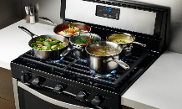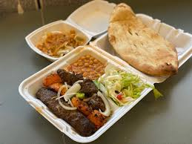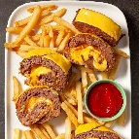 | YES | NO | NO | YES

Part D. ACKNOWLEDGEMENT

On behalf of the club(s) listed in this form, I certify that I have read the Food and Beverage Guidelines for Clubs and Organizations, and that I will ensure that the event will be in compliance with the guidelines provided by Student Life.

Student Name and Last Name: _______________________________________________
Student Signature: _______________________________________________
Date: _______________________________________________

Key
A. Small meeting or gathering for members only (not selling anything)
B. Event for members and other students (not selling anything)
C. Event for members and other students to sell and fundraise on campus property
D. Event for members and other students to sell and fundraise outside campus with a restaurant.

For questions, contact the Student Life office at the campus where the event will be hosted.
Email: ANStudentLife@nvcc.edu, Phone: 703-223.3147, Office CFH 224 Mon – Fri 9am – 5pm

Appendix A: NOVA Guidelines for the Service and Selling of Food Aad Beverage on Campus by Student Organizations

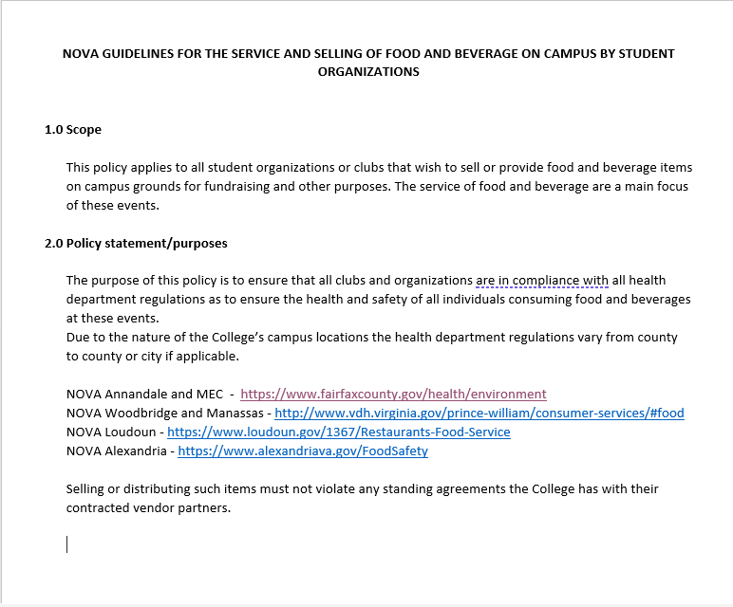

Appendix B: Be prepared for a Food Allergy Emergency
